Python Data Visualization Scenarios

Scenario 1 – Student Academic Performance
Scenario Question:
Create a scatter plot to visualize the relationship between students' attendance percentage and marks.
Python Program:
import matplotlib.pyplot as plt
attendance=[75,80,85,90,95]
marks=[60,68,75,85,95]
colors=["red","blue","green","orange","purple"]
plt.scatter(attendance,marks,c=colors)
plt.title("Student Academic Performance")
plt.xlabel("Attendance (%)")
plt.ylabel("Marks")
plt.show()
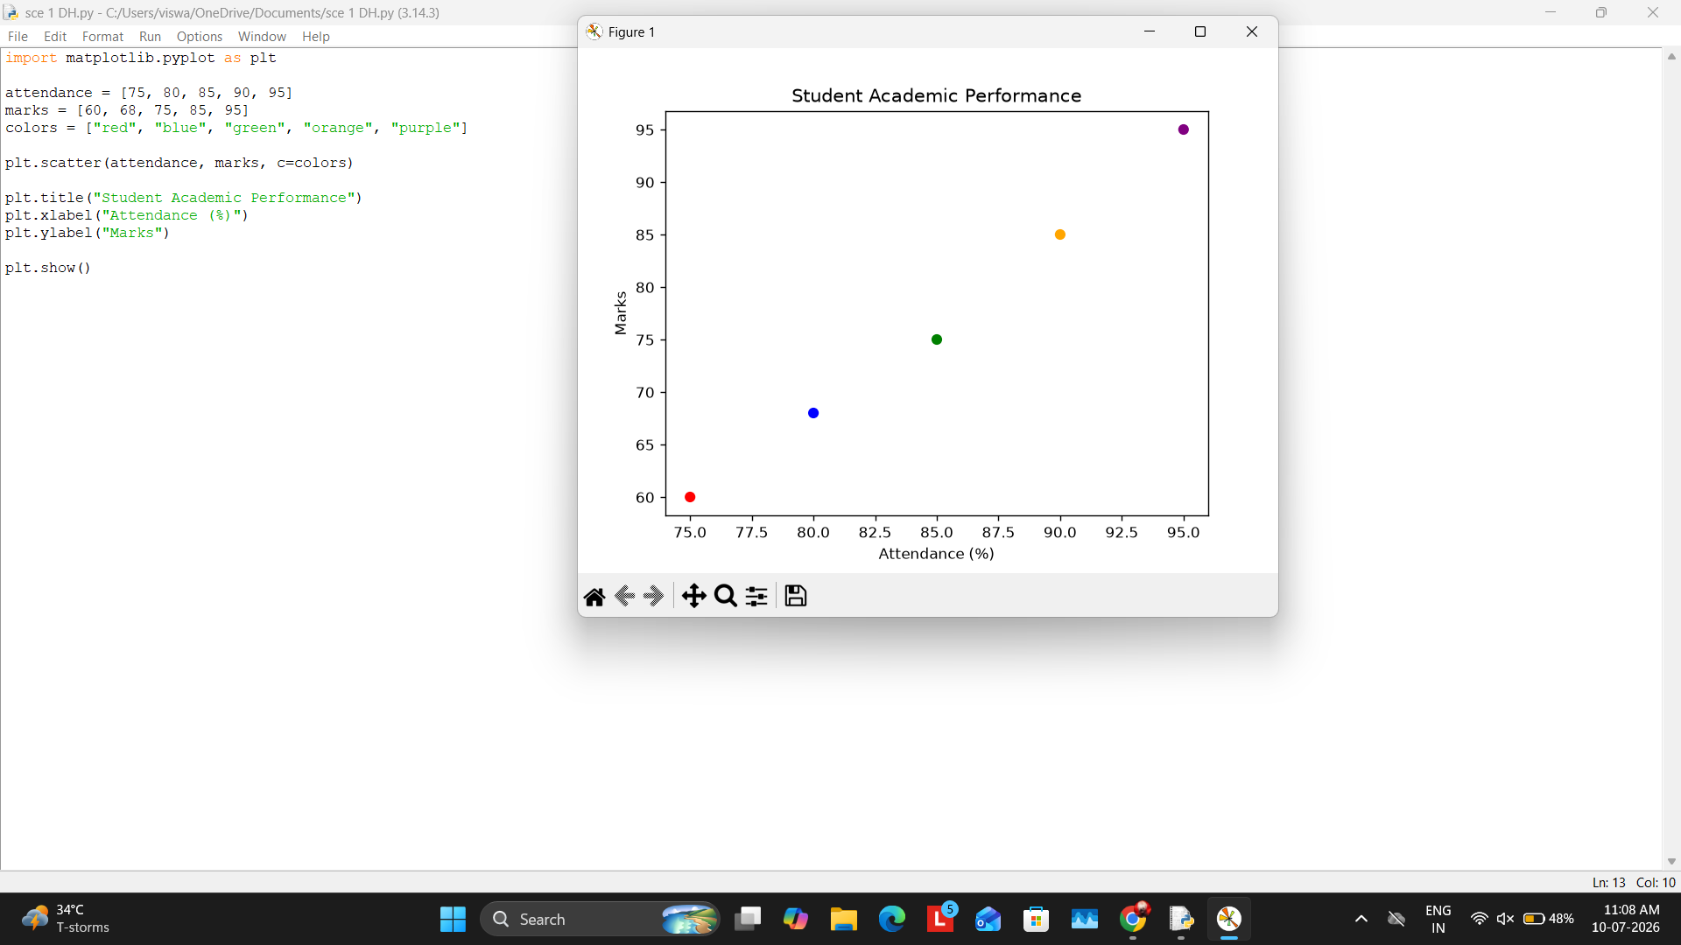

Scenario 2 – Electric Vehicle Market
Scenario Question:
Create a bubble chart showing battery capacity and price of electric vehicles.
Python Program:
import matplotlib.pyplot as plt
battery=[30,40,50,60,70]
price=[8,10,12,15,18]
size=[250,300,350,400,500]
plt.scatter(battery,price,s=size,color="green")
plt.title("Electric Vehicle Market")
plt.xlabel("Battery Capacity")
plt.ylabel("Price")
plt.show()
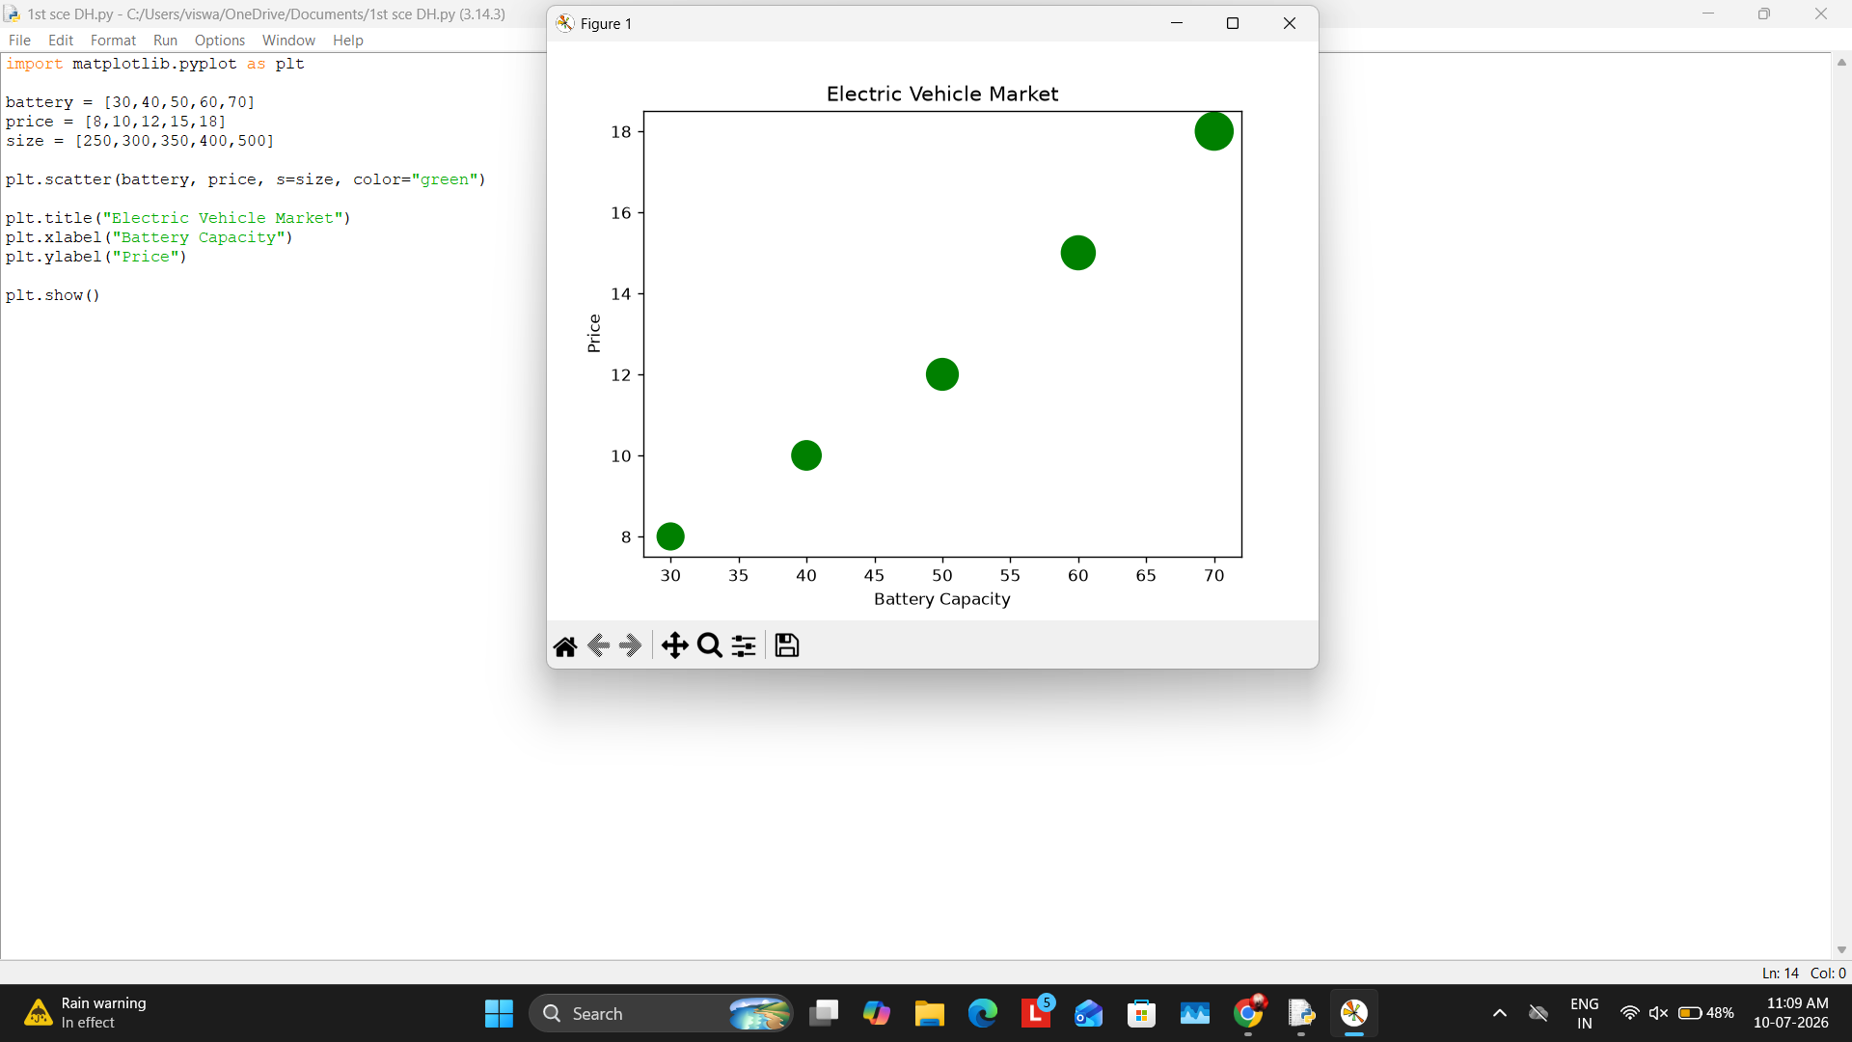

Scenario 3 – Hospital Patient Admissions
Scenario Question:
Create a bar chart to compare patient admissions across hospital departments.
Python Program:
import matplotlib.pyplot as plt
department=["Cardiology","ENT","Neuro","Ortho"]
patients=[120,80,60,100]
plt.bar(department,patients,color=["red","blue","green","orange"])
plt.title("Hospital Patient Admissions")
plt.xlabel("Department")
plt.ylabel("Number of Patients")
plt.show()
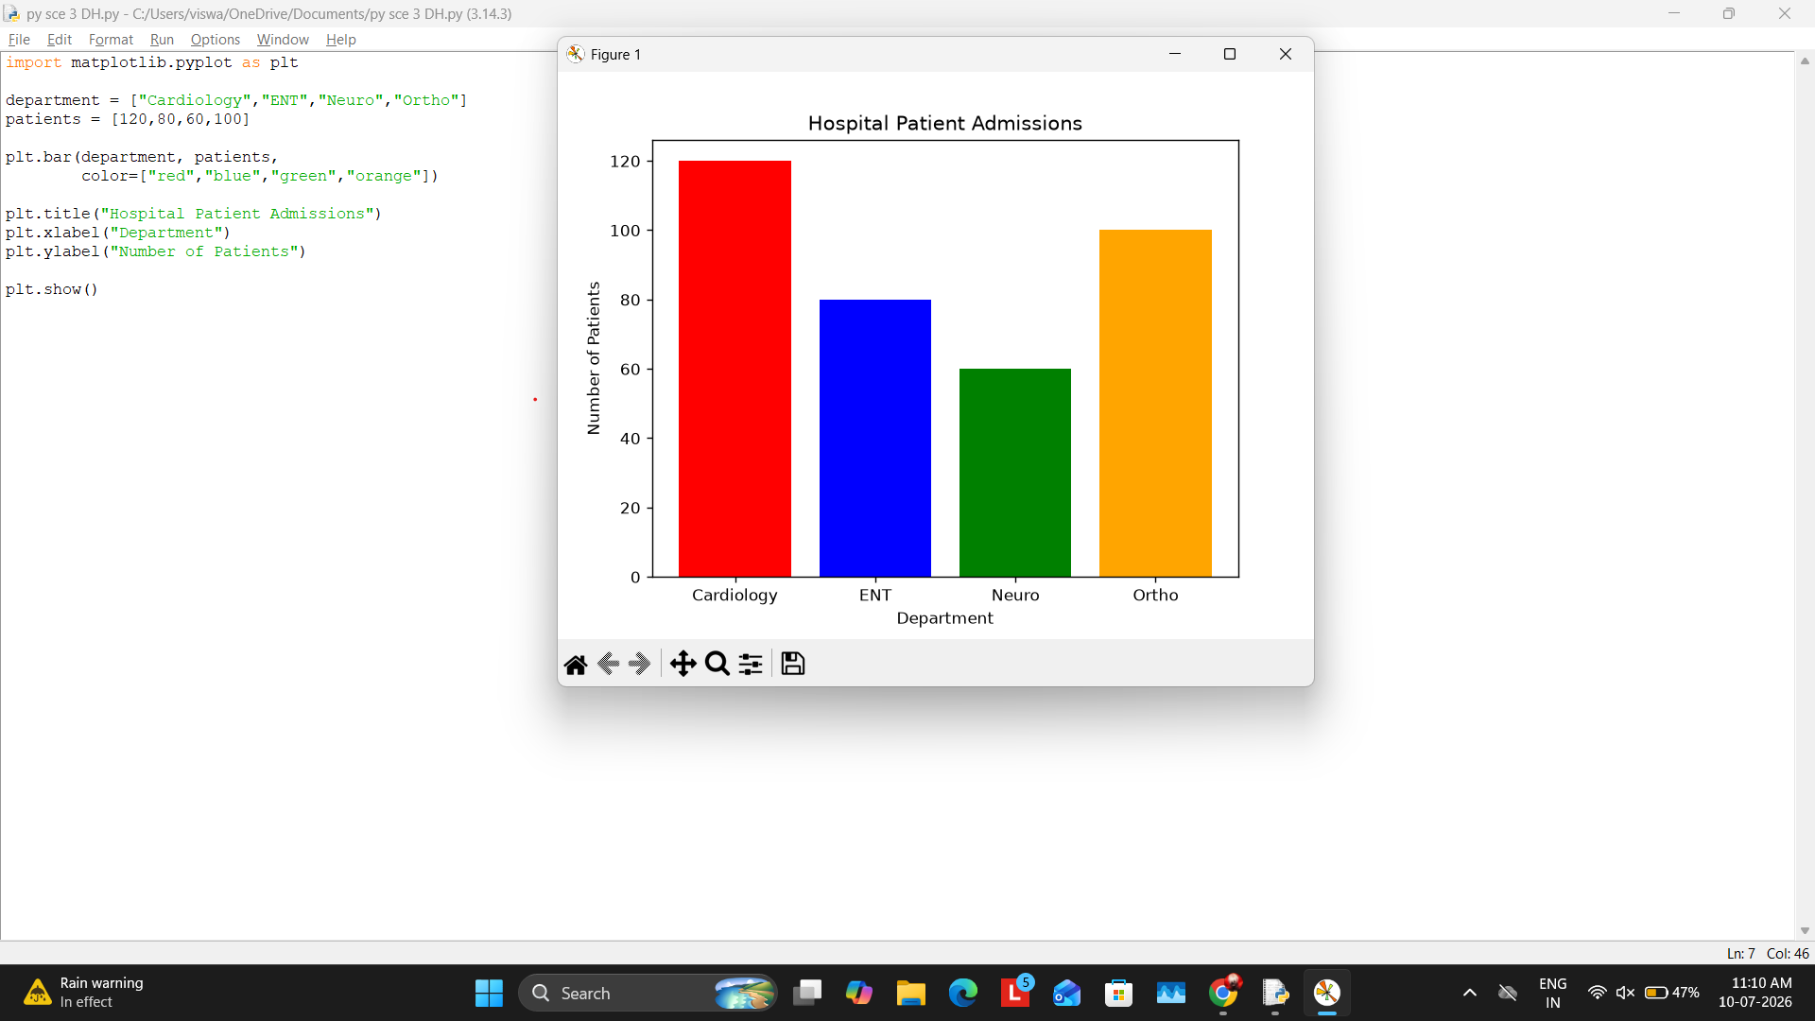

Scenario 4 – Weather Monitoring
Scenario Question:
Plot daily temperatures of different cities using a line chart.
Python Program:
import matplotlib.pyplot as plt
days=[1,2,3,4,5]
plt.plot(days,[30,31,32,31,30],label="Chennai")
plt.plot(days,[28,29,30,31,32],label="Delhi")
plt.plot(days,[26,27,28,29,30],label="Mumbai")
plt.title("Weather Monitoring")
plt.xlabel("Day")
plt.ylabel("Temperature")
plt.legend()
plt.show()
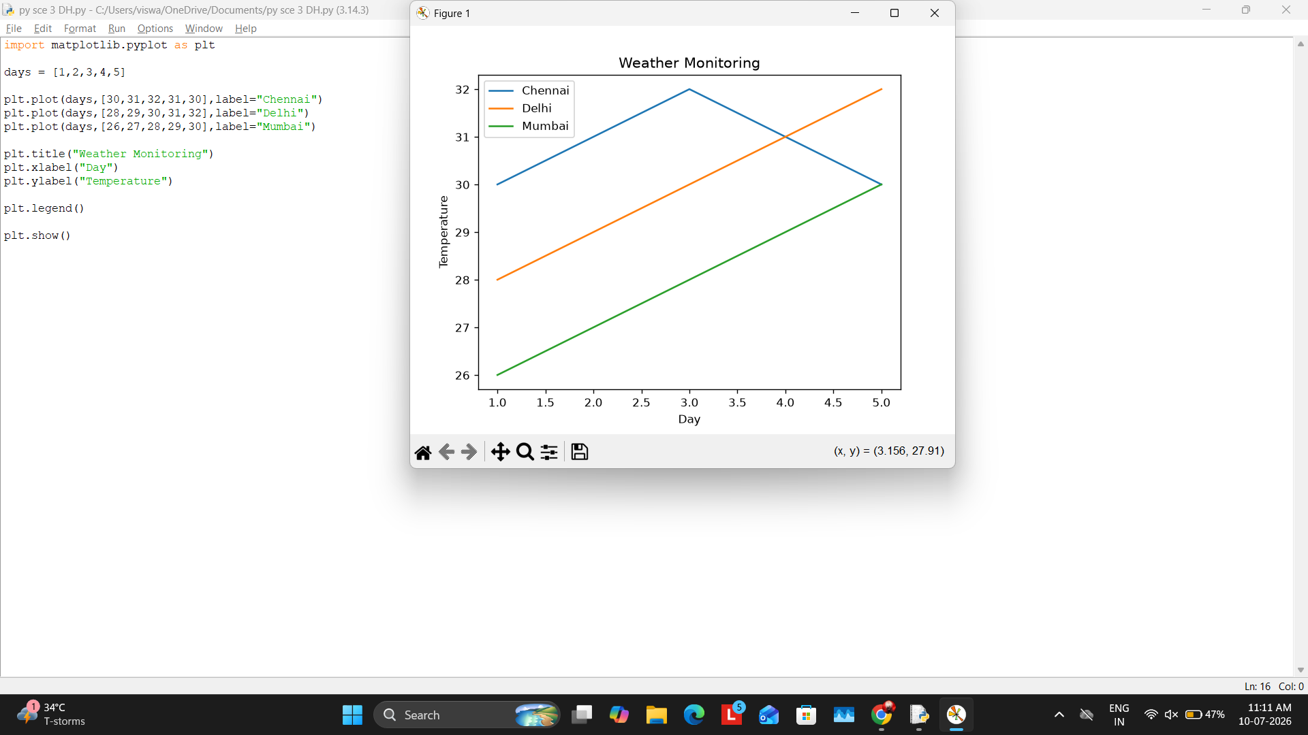

Scenario 5 – Supermarket Sales
Scenario Question:
Compare supermarket sales of two branches using a grouped bar chart.
Python Program:
import matplotlib.pyplot as plt
import numpy as np
category=["Food","Drinks","Snacks"]
branchA=[5000,4000,3000]
branchB=[6000,4500,3500]
x=np.arange(len(category)); w=0.3
plt.bar(x-w/2,branchA,width=w,label="Branch A")
plt.bar(x+w/2,branchB,width=w,label="Branch B")
plt.xticks(x,category)
plt.title("Supermarket Sales")
plt.legend()
plt.show()
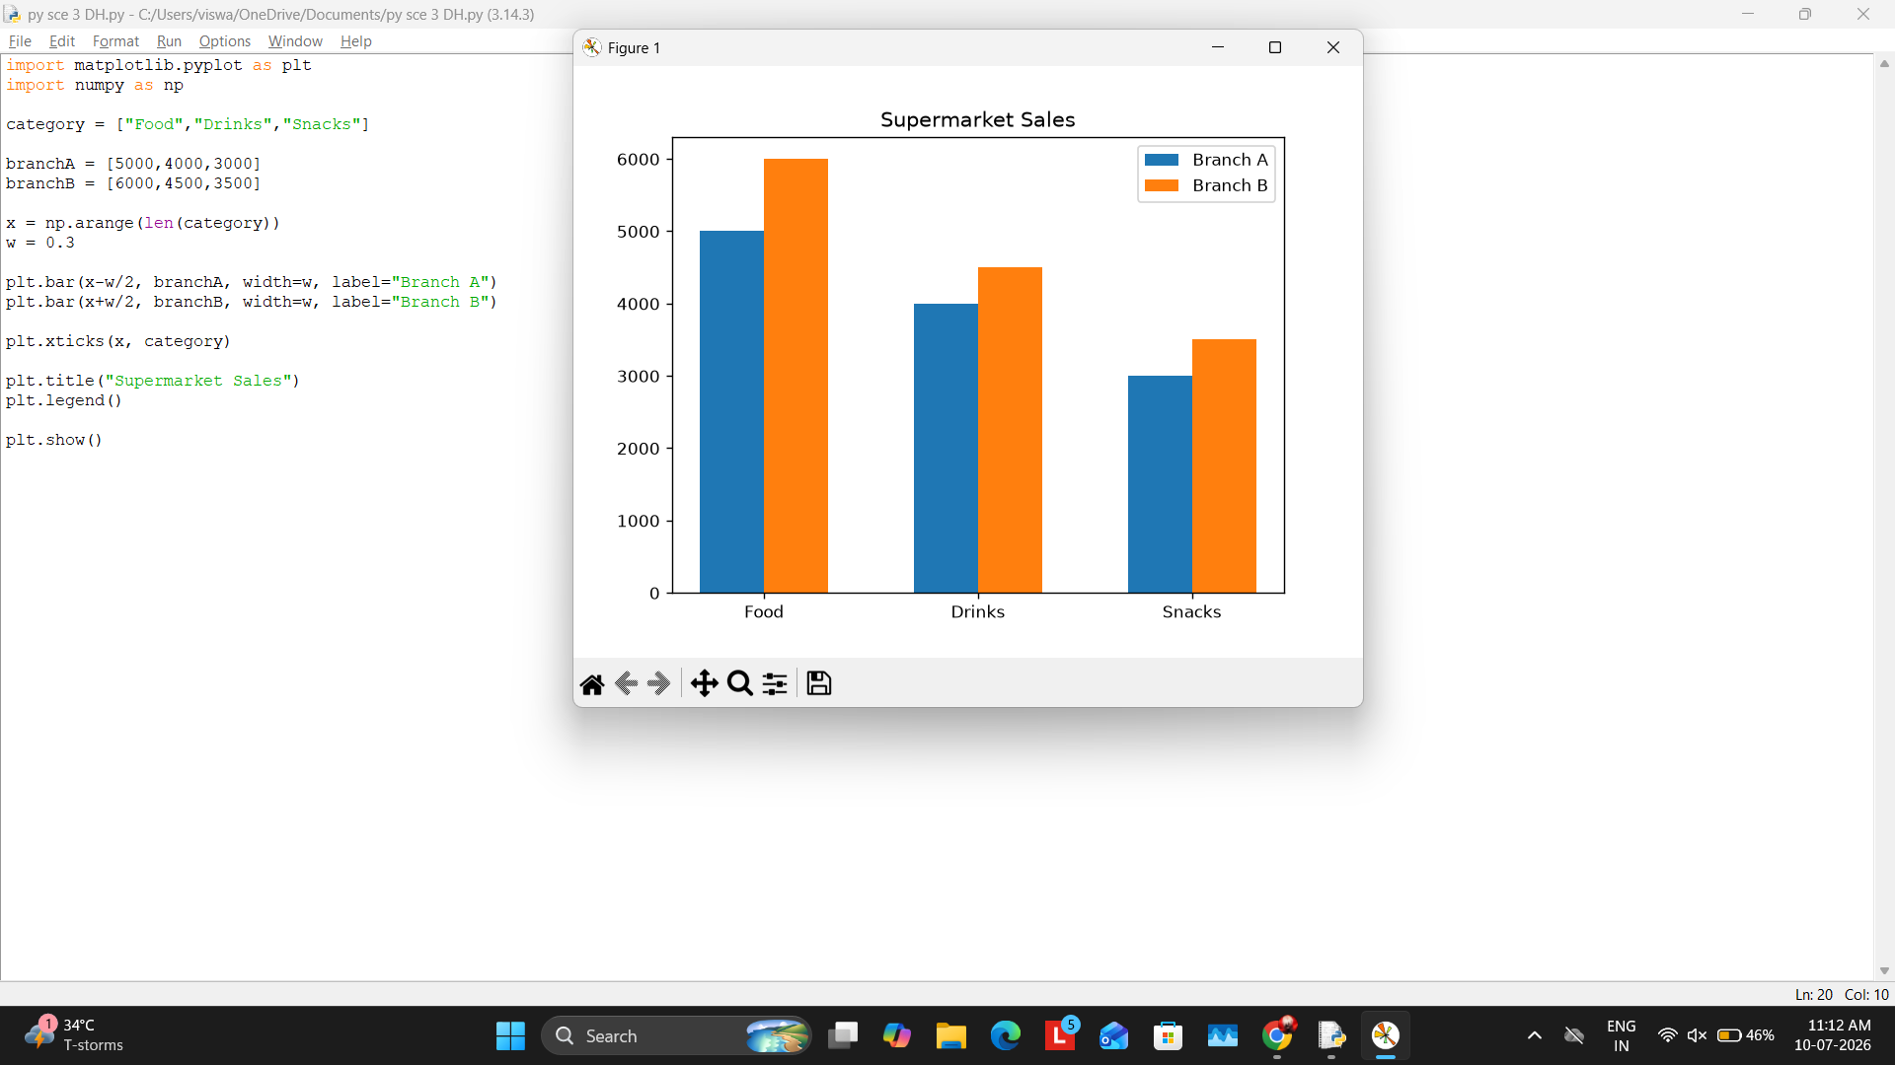

Scenario 6 – Salary Distribution
Scenario Question:
Create a histogram to visualize employee salary distribution.
Python Program:
import matplotlib.pyplot as plt
salary=[20000,25000,28000,30000,35000,40000,42000,45000,50000]
plt.hist(salary,bins=5,color="skyblue",edgecolor="black")
plt.title("Salary Distribution")
plt.xlabel("Salary")
plt.ylabel("Frequency")
plt.show()
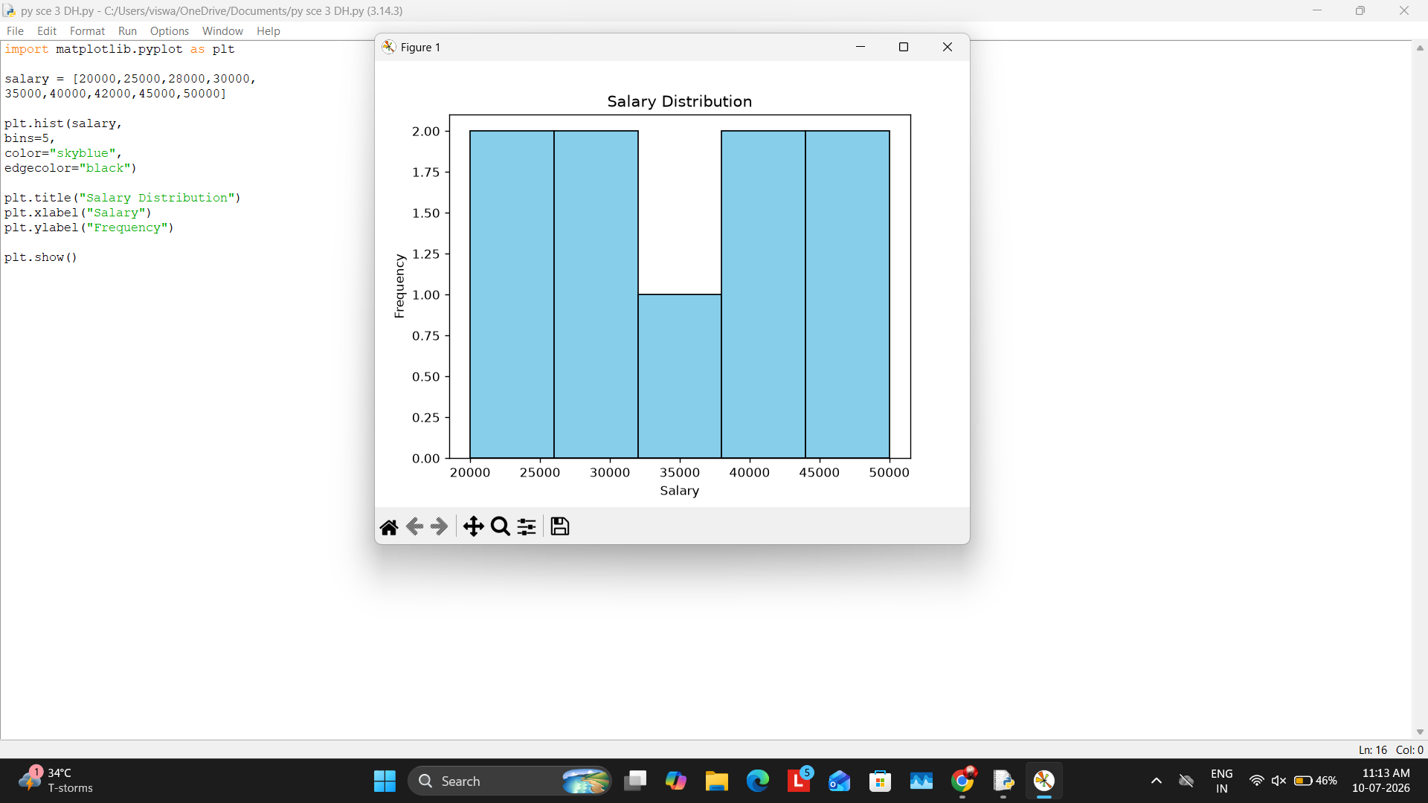

Scenario 7 – Smartphone Comparison
Scenario Question:
Create a scatter plot comparing smartphone RAM and price.
Python Program:
import matplotlib.pyplot as plt
ram=[4,6,8,12]
price=[15000,22000,30000,45000]
storage=[64,128,128,256]
plt.scatter(ram,price,s=storage,color="purple")
plt.title("Smartphone Comparison")
plt.xlabel("RAM")
plt.ylabel("Price")
plt.show()
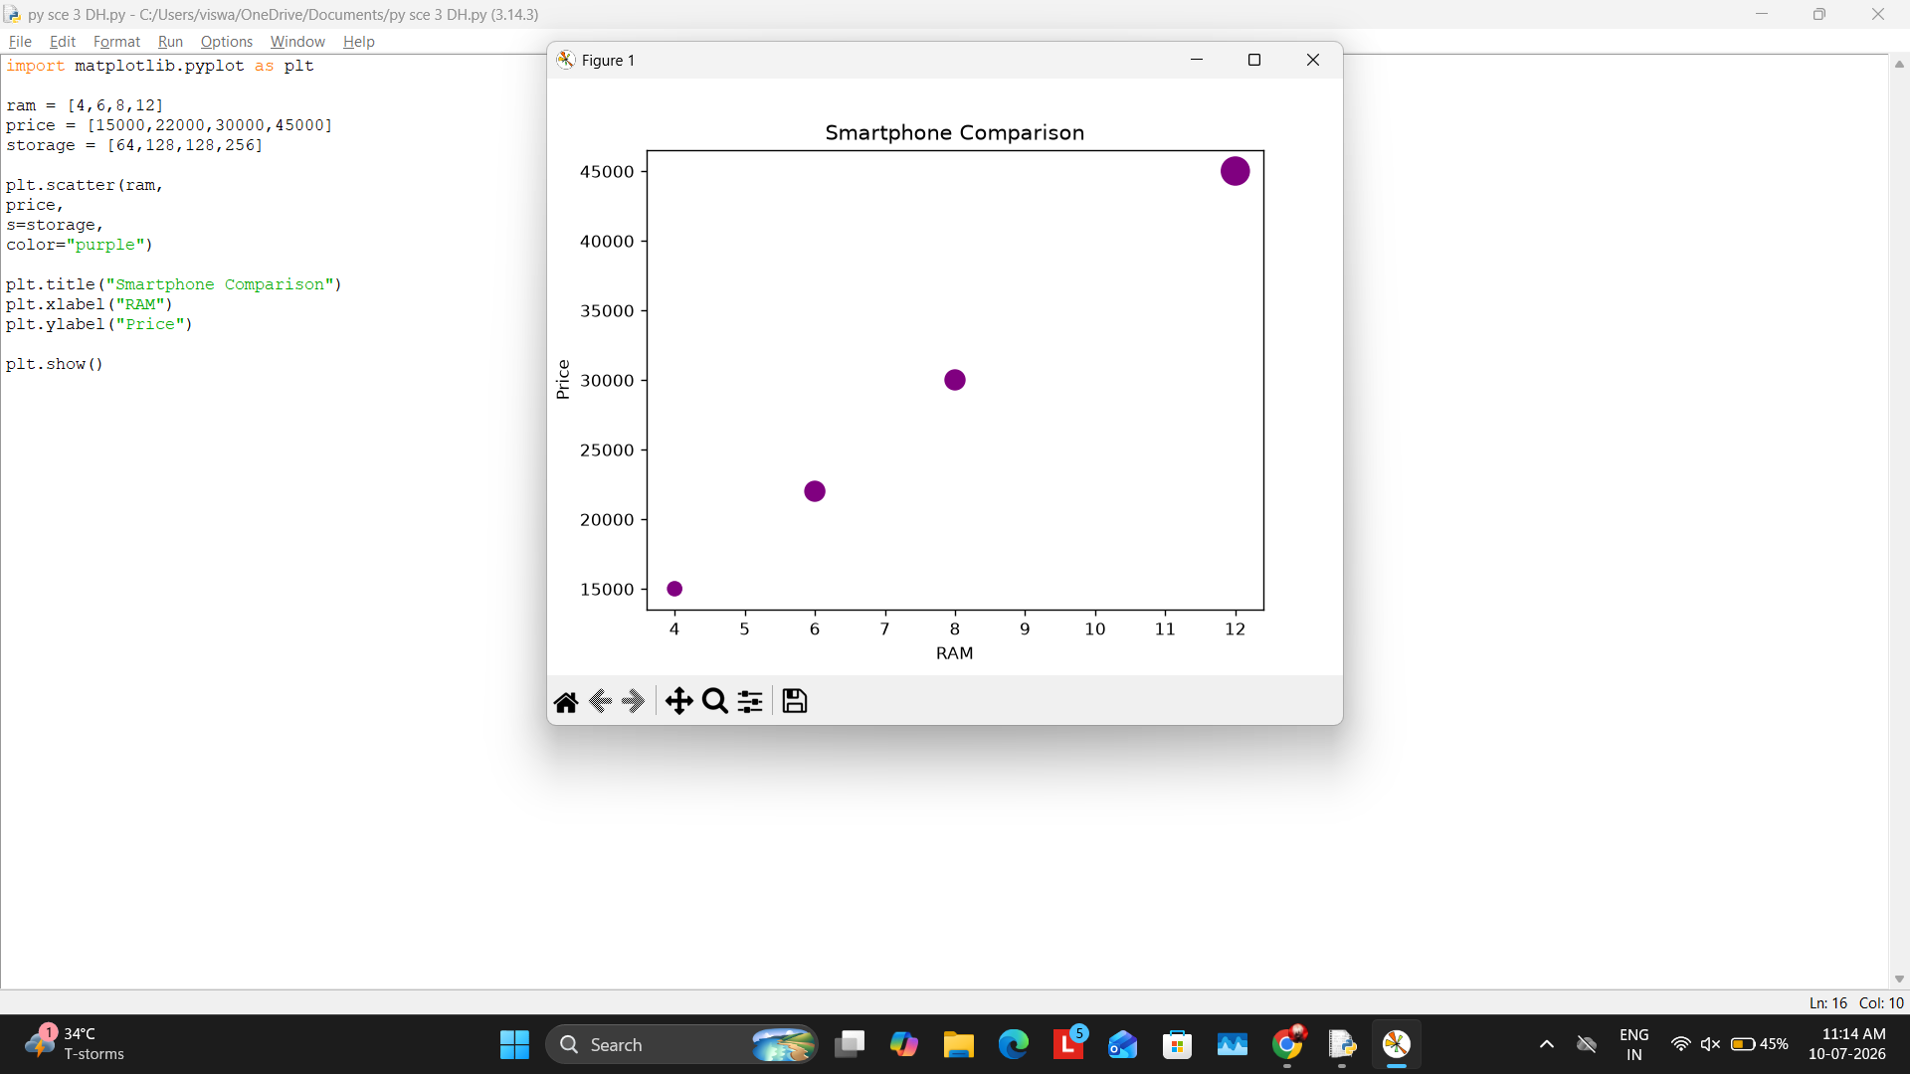

Scenario 8 – Online Movie Rating Analysis
Scenario Question:
Visualize movie ratings using a heatmap.
Python Program:
import matplotlib.pyplot as plt
import numpy as np
genres=["Action","Comedy","Drama","Horror","Sci-Fi"]
ratings=[8.2,7.5,9.1,6.8,8.7]
plt.imshow(np.array([ratings]),cmap="coolwarm",aspect="auto")
plt.xticks(range(len(genres)),genres)
plt.yticks([0],[""])
plt.colorbar(label="Average Rating")
plt.title("Online Movie Rating Analysis")
plt.xlabel("Movie Genre")
plt.show()
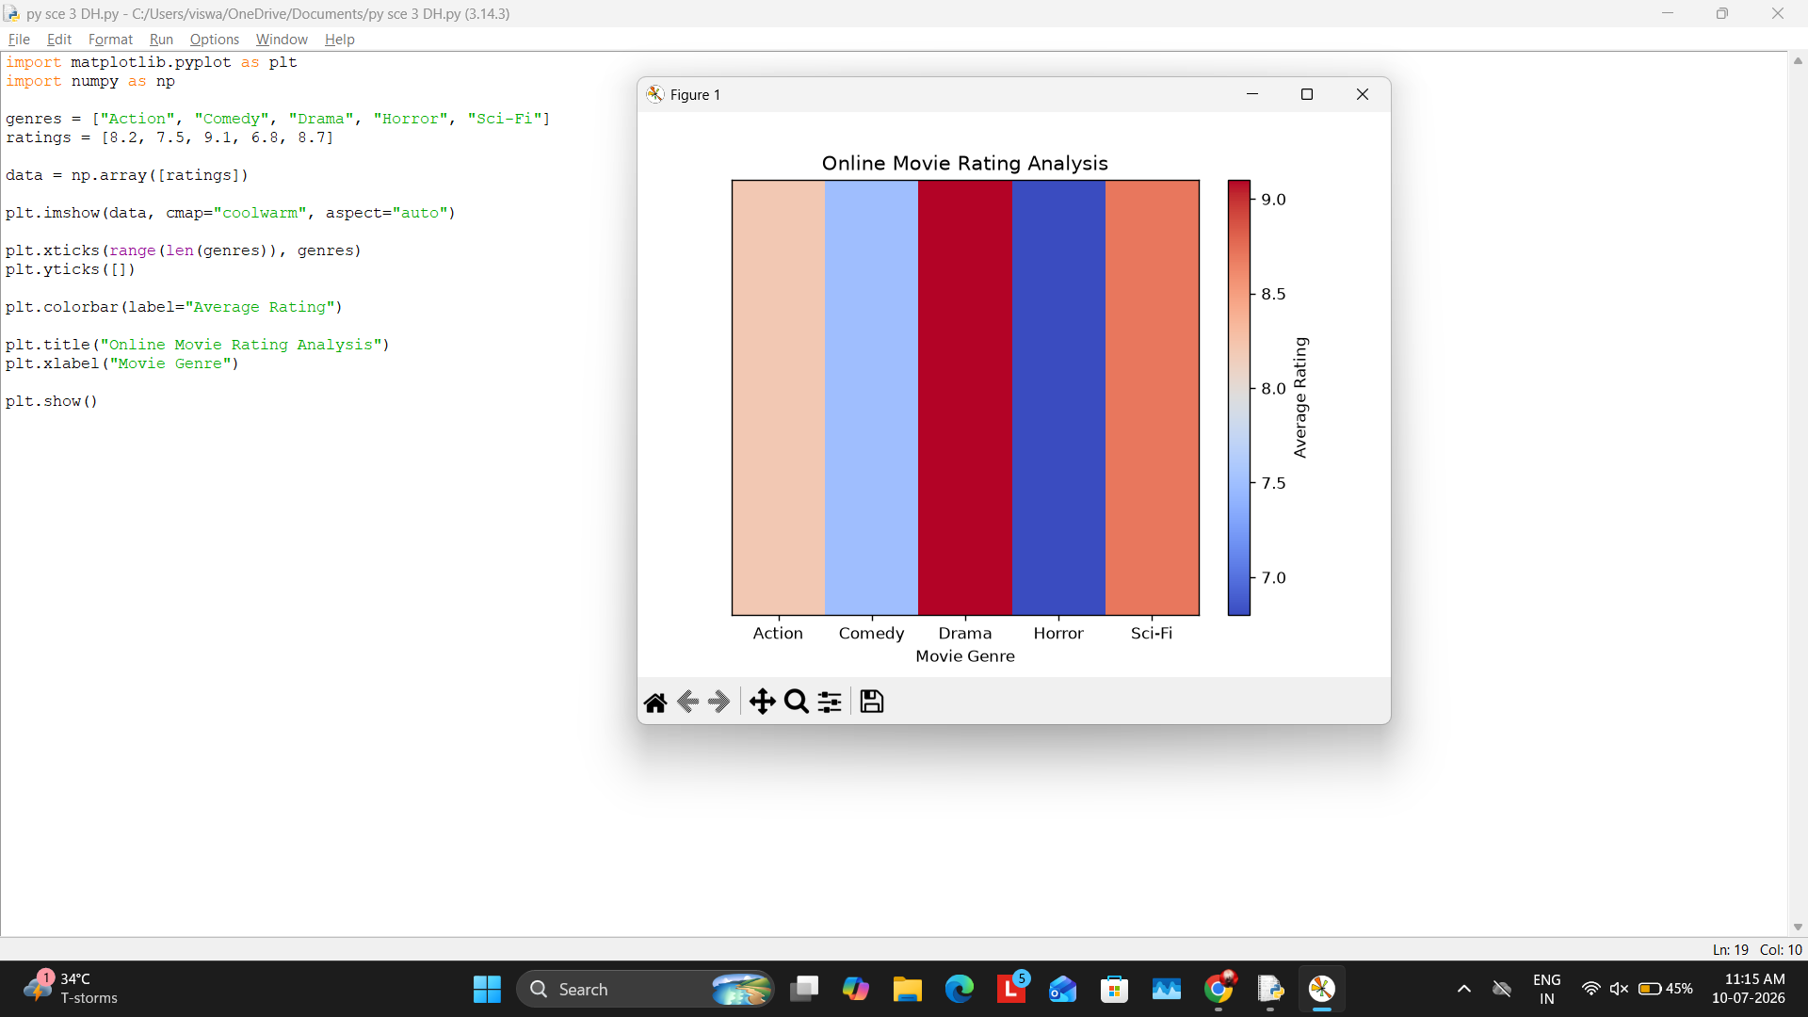

Scenario 9 – COVID-19 Active Cases
Scenario Question:
Create a bar chart showing COVID-19 active cases by state.
Python Program:
import matplotlib.pyplot as plt
states=["Tamil Nadu","Kerala","Karnataka","Andhra"]
cases=[1200,800,950,700]
plt.bar(states,cases,color="red")
plt.title("COVID-19 Active Cases")
plt.xlabel("State")
plt.ylabel("Cases")
plt.show()
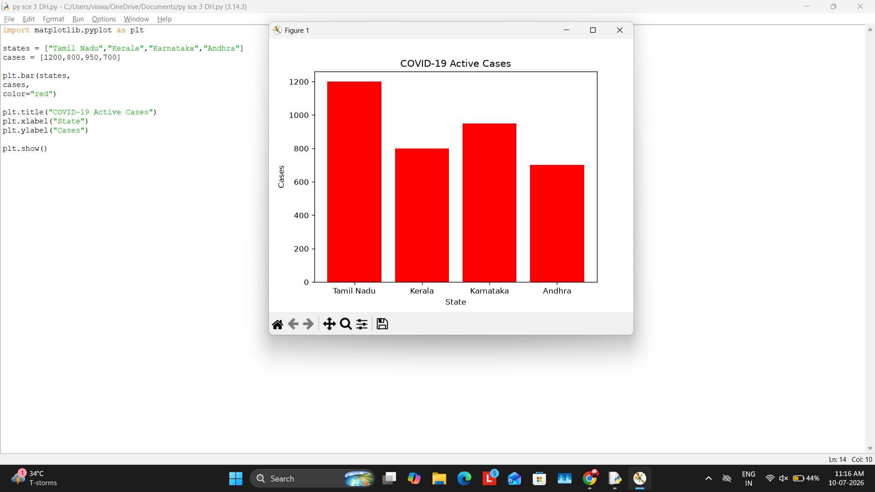

Scenario 10 – Iris Flower Classification
Scenario Question:
Create a scatter plot to classify iris flowers using Seaborn.
Python Program:
import seaborn as sns
import matplotlib.pyplot as plt
iris=sns.load_dataset("iris")
sns.scatterplot(data=iris,
x="sepal_length",
y="petal_length",
hue="species")
plt.title("Iris Flower Classification")
plt.show()
